

COMSATS University Islamabad, Lahore Campus
Terminal Exam – Spring 2021
Course Title: | Software Project Management |  |  |  | Course Code: |  | CSE494 |  | Credit Hours: | 3(2,1)
Course instructor/s: | Ms. Humaira Afzal |  |  |  | Program Name: |  | BS Software Engineering
Semester: | 7th | Batch: | SP19-BSE | Section: | A/B |  | Date: | 01-05-2021
Time Allowed: | 3 Hours |  |  |  | Maximum Marks: |  |  | 50
Student’s Name: |  |  |  |  | Reg. No.
Important Instructions /Guidelines:
- Attempt all the questions.
- Use of any communication device is not allowed.
- Manage your time accordingly.
- Return the question paper after exam.

Choose the right option for the following:
Question 1 [1*10]
- Which quantitative measure does COCOMO II modes use to estimate the project technical nature
- Function point
- Line of code
- Number of afferent and efferent connections among modules
- Both b & c
- A project charter documents how the project will be executed
- True
- False
- None of the above
- What is a Stakeholder?
- Person responsible for preparing the budget
- A third-party organization hired to do the job
- A person or organization that is actively involved in the project, or whose interest may be positively or negatively affected by execution or completion of the project
- A person or organization that defines the legal rules and procedures, economy and regulatory framework for your organization
- Cost Benefit Analysis is a technique performed by Project Manager
- True
- False
- True in some conditions
- None of the above
- Systematic arrangements of human resources
- Organizational Infrastructure
- Organizational Framework
- Organizational Portfolio
- Organizational Structure

- The payback time means
- The time taken to receive first payment of project
- The time taken to receive all the payment for the project is received
- The time taken to do the breakeven
- The time taken to completely deliver the project
- Primary guidance comes from functional manager and secondary from project manager while these priorities are reversed in:
- Projectized
- Weak Matrix
- Balance Matrix
- Projectized and Strong Matrix
- Projectized and Weak Matrix
- In which organizational structure, authority can make project manager arrogant
- Projectized
- Functional
- Strong matrix
- Balanced Matrix
- Weak Matrix
- Classic Triple Constraint considers the project constraints
- Scope, Time, Cost, Risks, Quality
- Scope, Schedule, Cost, Budget, Quality
- Scope, Time, Cost, Risks, Resources
- Time, Cost, Risks, Quality
- None of the above
- Enterprise Environmental Factors are
- Organizational Behavior, Culture, Distribution of work
- Resource Availability, Marketplace issues, Organizational culture
- Distribution of resources, social issues, Organizational Structure
- Competitive Advantage, Organizational governance, Employee capability

Question 2 [10 Marks] CLO<05>; Bloom Taxonomy Level: <Analyzing>
You are working on a blockchain project under XP agile method. You received a test case and now you want to communicate this information with your top manager. As a facilitator, you have identified the issues in the test cases and after root cause analysis, you got the conclusion of improper communication among developer and tester. Create a proper communication plan to be executed to mitigate these issues.
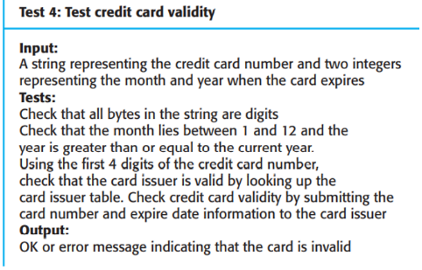
Question 3 [15 Marks] CLO<03>; Bloom Taxonomy Level: <Understanding>
- What are the factors that lead to the creation of a project? [5]
- How is portfolio management different from project management? In what conditions, are both linked to each other? [2+2]
- Is more than one critical path possible for a project? If yes, which one is required to choose? Do free floats impact the critical path? Justify. [3+3]
Question 4 [15 Marks] CLO<04>; Bloom Taxonomy Level: <Understanding>
COMSATS University is facing an issue of communication with other departments due to functional organizational structure. You have been appointed as Project Manager to head a web-based project with mobile application availability to be developed in 14 months. Each department can communicate with others instead of unpredictable responses waiting on email.
- Suggest some appropriate organizational structure for this scenario with justification. [5]
- Perform risk management with risk likelihood, impact and score and performance qualitative analysis on this basis. [5]
- How communication management approach can deal issues of unpredictable response wait. [5]

